Topic 3 :

Lesson 1:

In this lesson we will learn about java variable.

**Variable** : **Variable in Java** is a data container that stores the data values during Java program execution.

### How to initialize variables?

### While initializing a variable we need to take care of these things .

### datatype - Type of data that can be stored in this *variable*. (We will learn more about data types in upcoming lesson.)

### Variable Name – Name of variable which is given by programmer.

### Value – Value of variable .

### 

Lesson 2: **Data Types**

What Is Data-Types ?

As the name suggests, data types specify the type of data that can be stored inside Variables in java.

* **Data types are divided into two groups:**
* *Primitive data types.*
* *Non-Primitive Data types.*
* **Primitive Data Types -:**

1. Byte
2. short
3. int
4. long
5. float
6. double
7. boolean
8. char

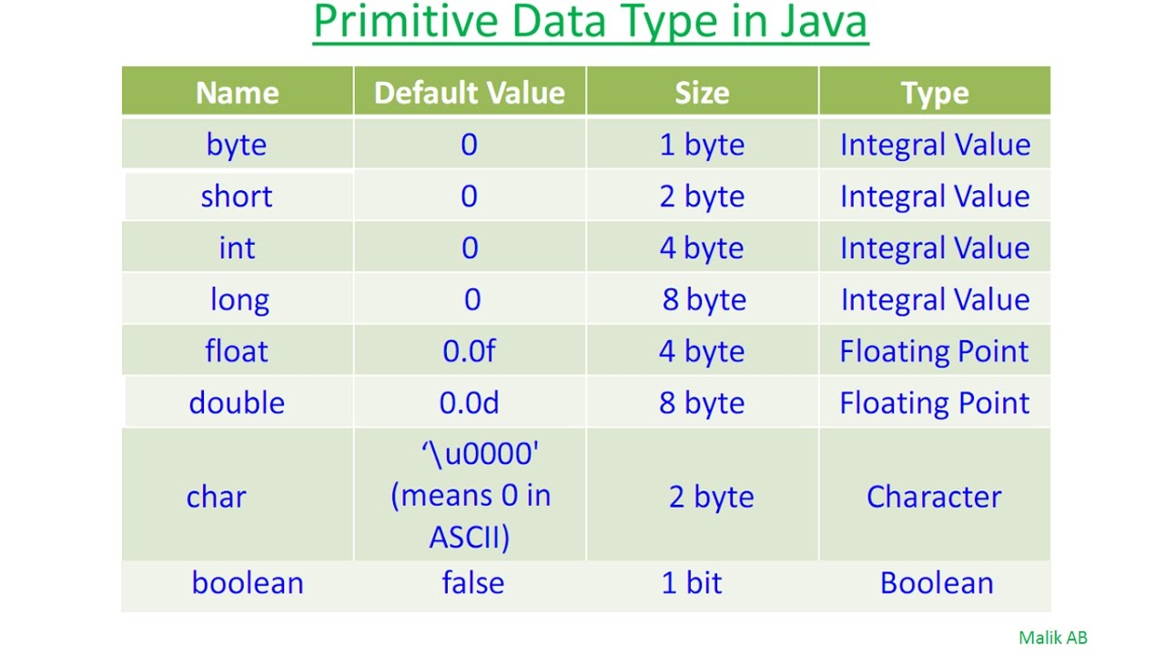

Java Primitive Data types

1. **byte Data type –** The ***byte****data type* can have values from **-128** to **127.**
2. **short Data type –** The ***short****data type* in Java can have values from **-32768** to **32767.**
3. **int Data type –** The ***int*** *data type* can have values from **-231** to **231 -1.**
4. **long Data type –** The ***long****data type* can have values from **-263** to **263 -1** .